Administration Manual

Setting up Project in Development Environment
What you need to set up the project: Eclipse 3.4.0, MySQL 5.0, Apache TomCat 6.0
In order to set up the project in Eclipse to work on it the following steps need to be taken.
- Check out "trunk/dev/web/" as a dynamic website named "Car_Pool_Project"
- Check out "trunk/dev/database" as a Java project names “database”
- Right click on "Car_Pool_Project" > build path > configure build path.Under "Projects" Tab add "database" project. Under "Source" Tab make sure "Car Pool Project/src" is in the list. Add it if it is not. Under Libraries Tab click add Library > Junit > JUnit 4 > Finish. Click on "Java EE Module Dependencies" on the left menu, Tick "database".
- Right click on "database" > build path > configure build path. Under Libraries Tab click Add Library > Junit > JUnit 3 > Finish.Under "Source" Tab make sure "database/src" is in the list. Add it if it is not. Right click on "lib/mysql-connector-java-5.1.6.jar" > build path > add to build path. Note you have to be in Java Perspective to do this.
- Lastly click on the Menu Bar > Project > Clean > clean all projects > Ok
Assuming you have installed mySQL log in as root or another user. Copy the contents of createDB_0_32 from trunk/dev/database/src/sql into the mySQL command line and this should create most of the tables, Then copy the contents of create-proxy-tables.sql then insert_proxy_data.sql then email.sql and finally smtp.sql to create and populate certain tables.

Now right-click index.jsp and select Run On Server. The webpage should run for you on your local host.

Most functions relating to the database can be added to car.pool.persistence in trunk/dev/database
All pages to be created should be added as jsps in trunk/dev/web

mySQL Connection
It is essential to ensure that the user and password you used to log into mySQL is the same as what is in the data.properties file in trunk/dev/database. Change it if it isn’t.

Google Keys
Also if the google map is not displaying for you it is likely because you do not have the correct Google Key. In the following pages:
addARide, displayResultsMaps, displayRouteMap, displayRouteMap2, myRideEdit and searchRides in the comments the local key and massey key have been specified. If you are running the site on your own machine change all the google keys to the local host one:
localhost key - ABQIAAAA7rDxBnSa8ztdEea-bXHUqRRKOMZEnoyerBNNN7XbrW5T80f1pxRxpg7l2VcFxiQk2L5RouYsGk3NqQ
The massey key for the site (http://seat-projects1:8080/Car_Pool_Project/) is
ABQIAAAAwEEggV_Hd8onlfSgA_kgZBTz-RVM6WN_1Yrxj3B45o6dXx3SPxRBd9zQMOS18U6DzRdS0kg6JbFdlA

To get a Google Key for your own site do the following -

1) Go to this google web site http://code.google.com/apis/base/signup.html
2) Enter your address in the http:// box.
3) Click sign me up

General Deployment
After doing the above.
- Ensure that the data.properties file has the correct username and password (the same as when you log into mySQL
- Ensure the Google keys are correct as mentioned above
- Create a backup database by going to MySQL>MySQLAdministrator>Log In>Backup>New Project>CarPool>Execute Backup Now
- Create a war file through Eclipse by right-clicking Car_Pool_Project>Export>War File
- The deploy the war file and backup database on server

The Admin User

When you first deploy this application the first thing you should do when it is up and running is to create the admin user. In the username and password login type in ‘admin’ as the username and ‘12weak34’ as the password. From here you will be taken to the admin registration page.
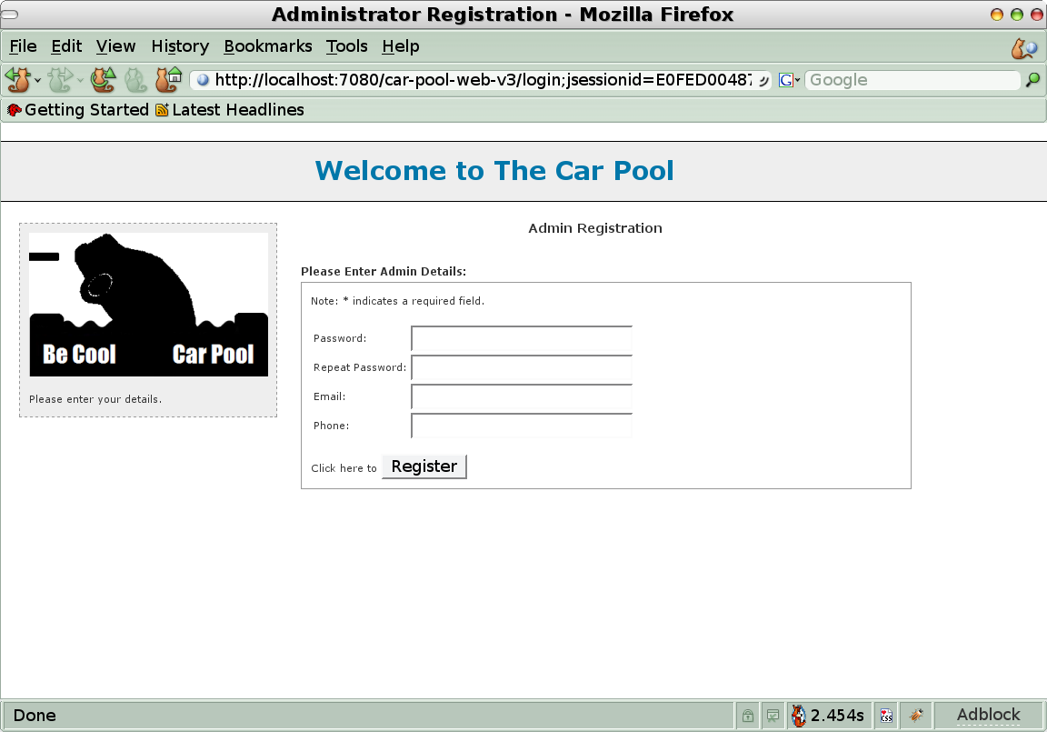
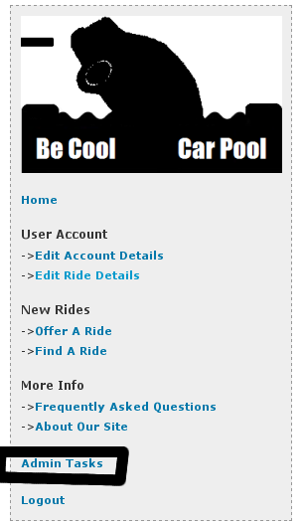
This is where you have to enter a new password, an email address, and a optional phone number. The email at the moment isn't used for anything, but in future, it could be used as a means to communicate with the admin of this site. Once you click the register button you will be redirected to the welcome page where you can now see a link on the left to the admin page.

The admin user is the only one who sees this admin link. You should click on this link to go here now to configure the site to use email, set it up to use a set of proxy servers if necessary, so OpenID authentication can take place, and also to import the list of streets into the databases locations table.

The Admin Page:

Locations
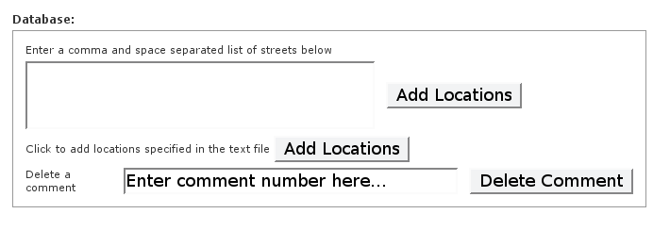
The street names have been specified in the streets.txt file located in trunk/dev/database. Currently when “Add Locations” is clicked from the admin page all the streets get added into the locations table with region Palmerston North. If this needs to be changed then the AddLocations class in car.pool.persistence.test in trunk/dev/database needs to be modified as does adminView.jsp in trunk/dev/web

Email and Proxy Setup

Email Setup.
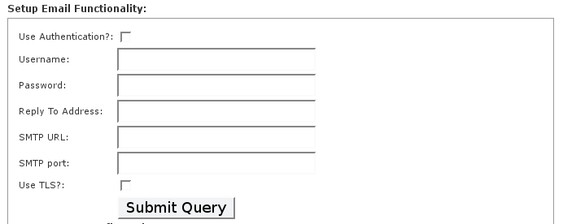
Here you can add the email settings that will be used by the site to send email. The values put in there will depend on the smtp server you are using, such as if you were using gmail you would use these settings:

Use Authentication: yes
Username: user
Password: your password
ReplyTo address: user@gmail.com
SMTP URL: smtp.gmail.com
SMTP Port: 587
Use TLS: yes

The username is the part just before the @ in your gmail address like user@gmail.com would put 'user' as their username. The settings used are up to you as the admin to find out.

Proxy Setup
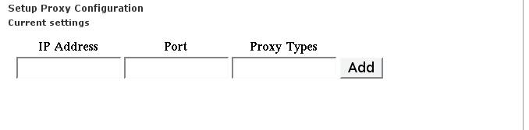
If you are behind a firewall and the only way out is through a proxy server for http connections, which are needed, you can set the site to use the proxy you want from here. If say you had a proxy server at the address of proxy.localhost on port 8080 you would put into the Ip Address field 'proxy.localhost', and in the port field '8080' and in the types field 'http'.

User and Ride List

A list of users registered in the system are printed out here, at the moment, that is all it is, but in the future the usefulness of this list could be expanded upon. There is also a list of all rides available at the time of viewing, and the usefulness of this list could be expanded upon in the future.
